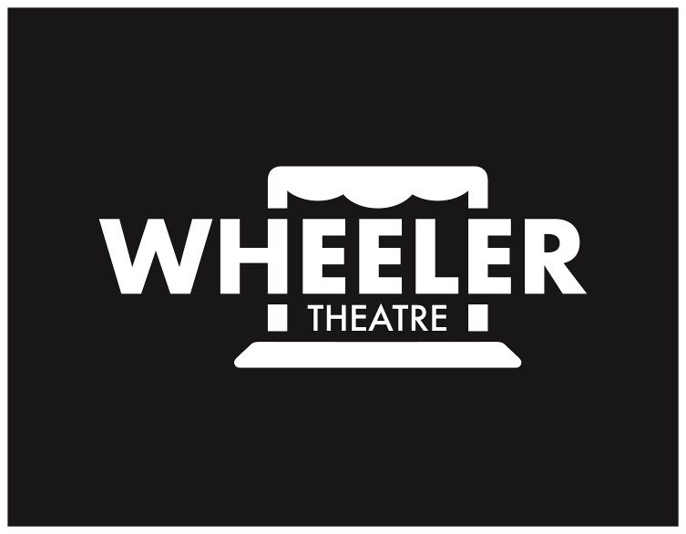 | Wheeler High School Theatre Program Ad Order Form  FREAKY FRIDAY the musical (January 2019)

Program Ads
Purchasing a program ad not only supports Wheeler High School Theater by defraying production costs, but provides another lasting memory for your actor.

Personal Ads
You can send a personal message to a cast member or group of cast members by purchasing a full, half or quarter page ad in the show program. The same ad will run in each program for all performances.

Business Advertisements
You can purchase a full page or half page program ad to advertise your business, or you can encourage a local area business to purchase ad space in our show program and support Wheeler Theater at the same time! For special business sponsorships and/or donations, please contact wheeler.theatre.boosters@gmail.com
There are no limits to the number of ads that can be purchased. The revenue will help to defray the cost of printing programs and producing the show!

Pricing Information
Pricing is as follows for personal messages and business advertisements:

Type | Size | Personal Ad | Business Ad
Full Page | 7 1/2” (h) x 4 1/2“ (w) | $100.00 | $500.00
Half Page | 3 1/2” (h) x 4 1/2" (w) | $50.00 | $250.00
Quarter Page | 1 3/4” (h) x 4 1/2” (w)  or 3 ½” (h) x 2 1/8 (w) | $25.00 | N/A
- For actual ad sizes refer to the templates on back of order form.

Formatting and Submittal Instructions
Actor Ads: Our program designer will be happy to design your actor’s ad for you at no extra cost. Or you can design your own that must fit the size specifications above.
Business Ads: Must submit finished artwork.

Submit the form and payment, then email the text and photo to wheeler.theatre.boosters@gmail.com. Use jpeg, bmp or tif formats for electronically transmitted photographs. If you are submitting a non-electronic photograph, provide an original and mark the back with your actor’s name if you’d like it returned to you. All program contents will be printed in black and white.

Wheeler High School Theatre Program Ad Order Form
FREAKY FRIDAY (January 2019)

Return only this page with full payment and any attachments (as identified above and shown on reverse side) to wheeler.theatre.boosters@gmail.com by November 15th 2019

Please make checks payable to: Wheeler Theatre Boosters
Indicate FREAKY FRIDAY in the memo section of your check.

Print as legibly as possible. Email questions to wheeler.theatre.boosters@gmail.com

Date: Amount: Payment Circle: Check Credit Card Cash

Actor or Business Name
Contact Name
Contact phone
Contact Email
Ad size  (Please circle one) | ¼ Page Horizontal ¼ Page Vertical  (¼ page ads not available for Business Ads) | ½ Page | Full Page
Special Instructions
Ad Submission (completed by WHS Theater) | Photo and Text Attached  Photo/Text or Artwork Submitted via email Artwork Needed

CUSTOMER RECEIPT

Thank You for Your Tax-Deductible Support of the Wheeler High School and the Musical Theatre Production of ANNIE, the Musical!

Purchaser/Company Name:

Actor/Crew Name (if applicable)

Size of Ad Purchased:
Amount paid:

Wheeler Theatre Foundation is a 501(c)3 non-profit organization. EIN# 82-1614105.

